Group 14 Autonomous Drone

Needs Statement:

People who walk or jog on trails wish to have a product that follows them as they move, providing them light should they walk at night, phone charging and music should they need it, and a carrier for a bottle or other small objects so that they may remain hands-free.

Objectives Statement:

The team will design a user-following, four-wheeled robot capable of charging a phone, playing its music, holding small objects, and lighting up a path in front of the user. The robot will utilize a structure appropriate for paved trails or tracks, and will employ various peripheral features to meet client needs.

Background:

Many people enjoy walking or jogging on trails, but typically do so outside of working hours, and possibly when it’s dark outside. In addition, walkers and joggers are easily encumbered by only a few conveniences (e.g. water bottle, cell phone, headphones) due to lack of carrying capabilities. It would be advantageous to the client if he/she could have a light source follow them to light up the trail, while providing a docking station for charging electronics and storing small objects.

Marketing Requirements:

* Affordable – minimize price.
* Battery life – robot should be able to operate for a minimum of one hour.
* Speed – robot must be able to keep pace with a person jogging (~8 mph).
* Functionality – robot must provide multiple functions to the user, and be easy to operate.
* Accurate – robot should be able to maintain a close following distance.
* Safety – robot will maintain safe distance from user, and will avoid obstacles so as to not to collide with objects or people.

Objective Tree:

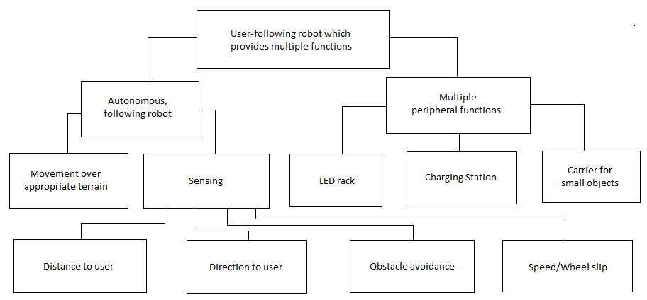

**Requirements Statement**

|  |  |  |
| --- | --- | --- |
| Marketing Requirements | Engineering Requirements | Justification |
| 1 | Should be able to run 12V motors at an average of 1A for approximately 60 minutes. | This is a realistic duration of time, giving the user plenty of operation off a single charge. |
| 2, 3 | System will utilize IR and ultrasonic sensors to track the user while avoiding obstacles. | IR provides a more accurate method of determining the user’s location and distance, and ultrasonic sensors are ideal for obstacle detection. |
| 4 | System cost will not exceed $150. | Based on competitive market prices for similar product. |
| 2 | The system will maintain a following distance of approximately five feet. | This following distance is far enough to be safe for the user, and close enough to be used effectively. |

Marketing Requirements:

1. System should last a reasonably long time.
2. System should be hands-free.
3. System should avoid obstacles.
4. System should be relatively low-cost.

**Tradeoff Matrices**

|  |  |  |  |  |  |
| --- | --- | --- | --- | --- | --- |
|  |  | **Output Power** | **Sensors** | **Following distance** | **Cost** |
|  |  | **+** | **+** | **+** | **-** |
| **Long-lasting** | **+** | ↓↓ | ↓ |  | ↓ |
| **Hands-free** | **+** |  | ↑↑ | ↑ | ↑ |
| **Avoids obstacles** | **+** |  | ↑↑ |  |  |
| **Cost** | **-** |  | ↓ |  | ↑↑ |

**House of Quality**

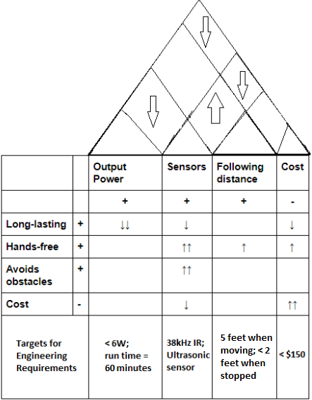

**Initial Design Concept**

The team’s initial design concept is a drone that acts both actively and passively using information gathered from various sensors. The drone will be a “follow-me” drone that utilizes an IR transmitter/receiver pair to accurately track the user. It will maintain a safe distance, slightly behind and above the user, and will feature an ultrasonic sensor to prevent obstacle collisions. The flight controller will be an Arduino Uno, and will interface with a small object, to be carried by the user, containing the IR transmitter. Additional peripheral functions (yet to be finalized) include LED displays, bright LED spotlights, and bluetooth speakers. The intention is for the drone to be versatile and reconfigurable enough to accommodate various peripheral functions.

**Revised Design Concept**

The team’s revised design concept is a 4-wheeled, ground-travelling robot equipped with the same major functions and capable of various peripheral functions. The robot will still follow the user, maintaining a five-foot distance while the user is jogging, and a shorter distance (less than or about 2 feet) when the user is stopped. Infrared sensors will still be used to track the target, and an ultrasonic sensor will still be used for collision avoidance. The robot will have a pedestal-type shaft mounted to the body which will hold the docking/charging station for a phone, and a small carrier for small objects like a water bottle. The robot’s movement and sensors will be controlled by an Arduino Uno.

**Draft System Design**

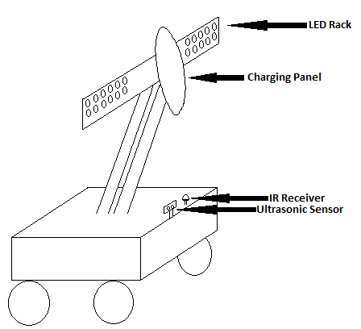

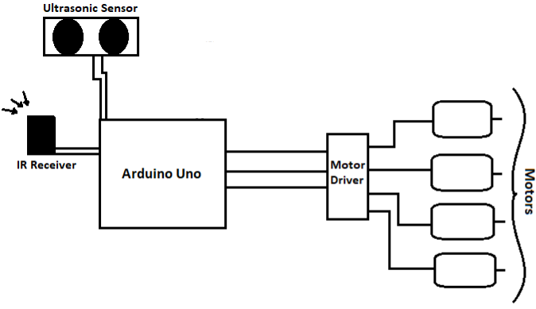

**Task List**

|  |  |  |
| --- | --- | --- |
| # | Description | Milestone |
| 1 | Determine exact functions |  |
| 2 | Gather parts |  |
| 3 | Assemble mobile portion |  |
| 4 | Program robot |  |
| 5 | Verify robot function (particularly with sensors) | **X** |
| 6 | Mount/wire docking station |  |
| 7 | Mount/integrate LEDs |  |
| 8 | Install carrier and peripherals | **X** |
| 9 | Build and install exterior/shell |  |
| 10 | Verify correct functions | **X** |

**Milestones**

The three milestones identified represent major accomplishments, i.e. the completion of a series of fundamental tasks. The first milestone will be after the mobile portion of the robot is complete (before anything else is mounted to the robot), programmed, and verified to work appropriately with its sensors (e.g. user tracking, obstacle avoidance). The second milestone will be the completion of the build of the entire robot, all mounted hardware included. The final milestone will be the verification that, once all hardware is mounted, and the robot is encased in a protective shell (shielding it from rain, mud, etc.), the robot functions without issues as expected.

**Work Breakdown Structure**

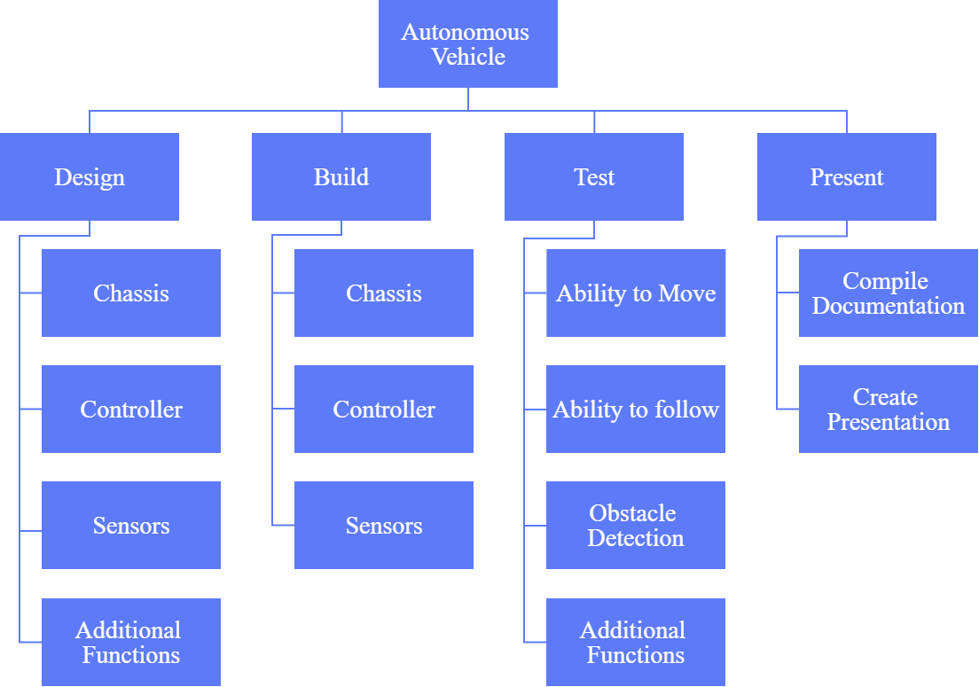

**Gantt Chart**

|  |  |  |  |  |  |  |  |  |  |  |  |  |  |  |  |  |  |
| --- | --- | --- | --- | --- | --- | --- | --- | --- | --- | --- | --- | --- | --- | --- | --- | --- | --- |
|  | Week 1 | Week 2 | Week 3 | Week 4 | Week 5 | Week 6 | Week 7 | Week 8 | Week 9 | Week 10 | Week 11 | Week 12 | Week 13 | Week 14 | Week 15 | Week 16 | Progress Estimate |
|  | 21-Aug | 27-Aug | 3-Sep | 10-Sep | 17-Sep | 24-Sep | 1-Oct | 8-Oct | 15-Oct | 22-Oct | 29-Oct | 5-Nov | 12-Nov | 19-Nov | 26-Nov | 3-Dec | **Total: 53%** |
| Design |  |  |  |  |  |  |  |  |  |  |  |  |  |  |  |  | **80%** |
| Chassis |  |  |  |  |  |  |  |  |  |  |  |  |  |  |  |  | 90% |
| Controller |  |  |  |  |  |  |  |  |  |  |  |  |  |  |  |  | 90% |
| Software |  |  |  |  |  |  |  |  |  |  |  |  |  |  |  |  | 80% |
| Sensors |  |  |  |  |  |  |  |  |  |  |  |  |  |  |  |  | 60% |
| Additional Functions |  |  |  |  |  |  |  |  |  |  |  |  |  |  |  |  | TBD |
| Build |  |  |  |  |  |  |  |  |  |  |  |  |  |  |  |  | **73%** |
| Chassis |  |  |  |  |  |  |  |  |  |  |  |  |  |  |  |  | 70% |
| Controller |  |  |  |  |  |  |  |  |  |  |  |  |  |  |  |  | 80% |
| Sensors |  |  |  |  |  |  |  |  |  |  |  |  |  |  |  |  | 70% |
| Test |  |  |  |  |  |  |  |  |  |  |  |  |  |  |  |  | **57%** |
| Ability to move |  |  |  |  |  |  |  |  |  |  |  |  |  |  |  |  | 90% |
| Ability to follow |  |  |  |  |  |  |  |  |  |  |  |  |  |  |  |  | 0% |
| Obstacle detection |  |  |  |  |  |  |  |  |  |  |  |  |  |  |  |  | 80% |
| Additional Functions |  |  |  |  |  |  |  |  |  |  |  |  |  |  |  |  | TBD |
| Present |  |  |  |  |  |  |  |  |  |  |  |  |  |  |  |  | **0%** |
| Compile Documentation |  |  |  |  |  |  |  |  |  |  |  |  |  |  |  |  | 0% |
| Create Presentation |  |  |  |  |  |  |  |  |  |  |  |  |  |  |  |  | 0% |